CSC430/530 – Database Management Systems

Assignment #2 – EER to Relational Model Mapping

In this assignment, you are to map provided ER and EER diagrams into Relational Model schemas following steps described in “Lesson 5.1 - EER to Relational Model Mapping”.

1. Consider following ER diagram for a database that can be used to keep track of transport ships and their locations for maritime authorities. Note: assume port names to be unique across all states/countries and seas/oceans/lakes. Map this diagram into a relational schema and specify all the primary & foreign keys. **Describe each step of the mapping process.** For example:

*Step 1 - mapping regular entities: SHIP, SHIP_TYPE, STATE/COUNTRY, and SEA/OCEAN/LAKE.*

* + *Regular entity SHIP mapped as SHIP relation. All simple attributes are included. Attribute “Sname”*

*is chosen as a primary key.*

* + *Regular entity SHIP_TYPE mapped as SHIP_TYPE relation. All simple attributes are included. Attribute “Type” is chosen as a primary key …*

…

*Step 4 - mapping binary 1:N relationships: TYPE, ON, and HOME_PORT.*

* + *1:N relationship TYPE is mapped as a foreign key attribute “Type” in SHIP relation (“N” side) that*

*corresponds to “Type” primary key attribute in SHIP_TYPE relation (“1” side) …*

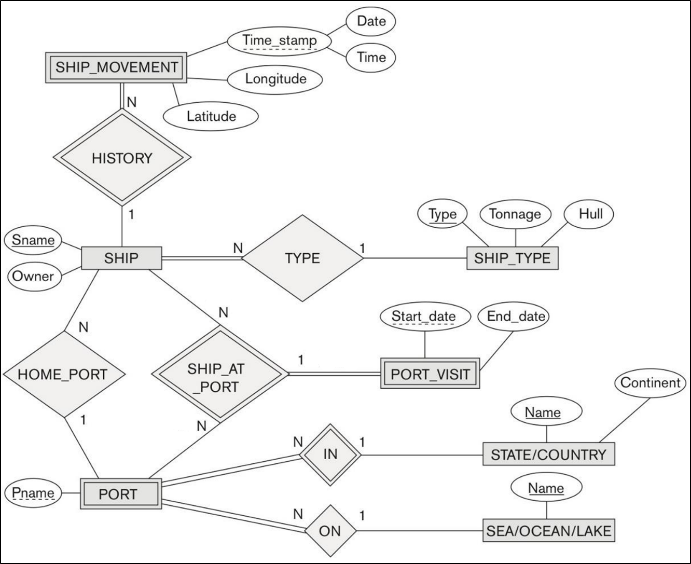

**Step 1 - mapping regular entities: SHIP, SHIP_TYPE, STATE/COUNTRY, SEA/OCEAN/LAKE.**

* **Regular entity SHIP mapped as SHIP relation. All simple attributes are included. Attribute "Sname" is chosen as a primary key.**
* **Regular entity SHIP_TYPE mapped as SHIP_TYPE relation. All simple attributes are included. Attribute "Type" is chosen as a primary key.**
* **Regular entity STATE/COUNTRY mapped as STATE/COUNTRY relation. Attribute "Name" is chosen as a primary key.**
* **Regular entity SEA/OCEAN/LAKE mapped as SEA/OCEAN/LAKE relation. All simple attributes are included. Attribute "Name" is chosen as a primary key.**

**Step 2 - mapping weak entities: SHIP_MOVEMENT, PORT_VISIT, PORT**

* **Weak entity SHIP_MOVEMENT mapped as SHIP_MOVEMENT relation. All simple attributes are included. Attribute “Sname” is chosen as a foreign key attribute that corresponds to “Sname” primary key attribute in SHIP relation. Attributes “Date”, “Time”, and "Sname" are chosen as primary key attributes in SHIP_MOVEMENT relation.**
* **Weak entity PORT_VISIT mapped as PORT_VISIT relation. All simple attributes are included. Attribute “Pname” is chosen as a foreign key attribute that corresponds to “Pname” primary key attribute in PORT relation. Attribute “Sname” is chosen as a foreign key attribute that corresponds to “Sname” primary key attribute in SHIP relation. Attributes “Start_date”, "Pname", and "Sname" are chosen as primary key attributes in PORT_VISIT relation.**
* **Weak entity PORT mapped as PORT relation. Attribute “SC_Name” is chosen as a foreign key attribute that corresponds to “Name” primary key attribute in STATE/COUNTRY relation. Attributes “Pname” and "SC _Name" are chosen as primary key attribute in PORT relation.**

**Step 3 - mapping binary 1:1 relationships:**

**- N/A**

**Step 4 - mapping binary 1:N relationships: TYPE, ON,HOME_PORT.**

* **1:N relationship TYPE is mapped as a foreign key attribute “SType” in SHIP relation (“N” side) that corresponds to “Type” primary key attribute in SHIP_TYPE relation (“1” side).**
* **1:N relationship ON is mapped as a foreign key attribute “SOL_Name” in PORT relation (“N side) that corresponds to “Name” primary key attribute in SEA/OCEAN/LAKE relation (“1” side).**
* **1:N relationship HOME_PORT is mapped as a foreign key attribute “Pname” in SHIP relation (“N” side) that corresponds to “Pname” primary key attribute in PORT relation (“1” side).**

**Step 5 - mapping binary M:N relationships: SHIP_AT_PORT.**

**- N/A**

**Step 6 - mapping multivalued attributes**

**- N/A**

**Step 7 - mapping n-ary relationships:**

**- N/A**

**Step 8 - mapping specializations and generalizations:**

**- N/A**

**Step 9 - mapping unions:**

**- N/A**

|  |  |  |  |  |  |  |  |  |  |  |  |  |  |  |  |  |  |  |
| --- | --- | --- | --- | --- | --- | --- | --- | --- | --- | --- | --- | --- | --- | --- | --- | --- | --- | --- |
| **SHIP** | | |  | |  | |  | |  | |  | |  | |  | |  | |
| Sname | Stype | Pname | | Owner | |  | |  | |  | |  | |  | |  | |
|  |  |  | |  | |  | |  | |  | |  | |  | |  | |
| **SHIP_TYPE** | | |  | |  | |  | |  | |  | |  | |  | |  | |
| Type | Tonnage | Hull | |  | |  | |  | |  | |  | |  | |  | |
|  |  |  | |  | |  | |  | |  | |  | |  | |  | |
| **STATE/COUNTRY** | | |  | |  | |  | |  | |  | |  | |  | |  | |
| Name | Continent |  | |  | |  | |  | |  | |  | |  | |  | |
|  |  |  | |  | |  | |  | |  | |  | |  | |  | |
| **SEA/OCEAN/LAKE** | | |  | |  | |  | |  | |  | |  | |  | |  | |
| Name |  |  | |  | |  | |  | |  | |  | |  | |  | |
|  |  |  | |  | |  | |  | |  | |  | |  | |  | |
| **SHIP_MOVEMENT** | | |  | |  | |  | |  | |  | |  | |  | |  | |
| Date | Time | Sname | | Longitude | | Latitude | |  | |  | |  | |  | |  | |
|  |  |  | |  | |  | |  | |  | |  | |  | |  | |
| **PORT_VISIT** | | |  | |  | |  | |  | |  | |  | |  | |  | |
| Start_date | Sname | Pname | | End_date | |  | |  | |  | |  | |  | |  | |
|  |  |  | |  | |  | |  | |  | |  | |  | |  | |
| **PORT** | | |  | |  | |  | |  | |  | |  | |  | |  | |
| Pname | SCname | SOLname | |  | |  | |  | |  | |  | |  | |  | |
|  |  |  | |  | |  | |  | |  | |  | |  | |  | |
|  |  |  | |  | |  | |  | |  | |  | |  | |  | |
|  |  |  | |  | |  | |  | |  | |  | |  | |  | |
|  |  |  | |  | |  | |  | |  | |  | |  | |  | |

1. Consider following EER diagram for a car dealer database. Map this diagram into a relational schema and specify all the primary & foreign keys. For the VEHICLE to CAR/TRUCK/SUV specialization, pick one of the options discussed in class (8A, 8B, 8C, 8D). Justify your choice.

**Describe each step of the mapping process.** For example:

*Step 1 - mapping regular entities: VEHICLE, SALESPERSON, CUSTOMER.*

* + *Regular entity type VEHICLE is mapped as a VEHICLE relation. All simple attributes are included.*

*Attribute “Vin” is chosen as a primary key …”*

*…*

*Step 7 – mapping n-ary relationships: SALE …*

*Step 8 – mapping specializations and generalizations: CAR, TRUCK, SUV …*

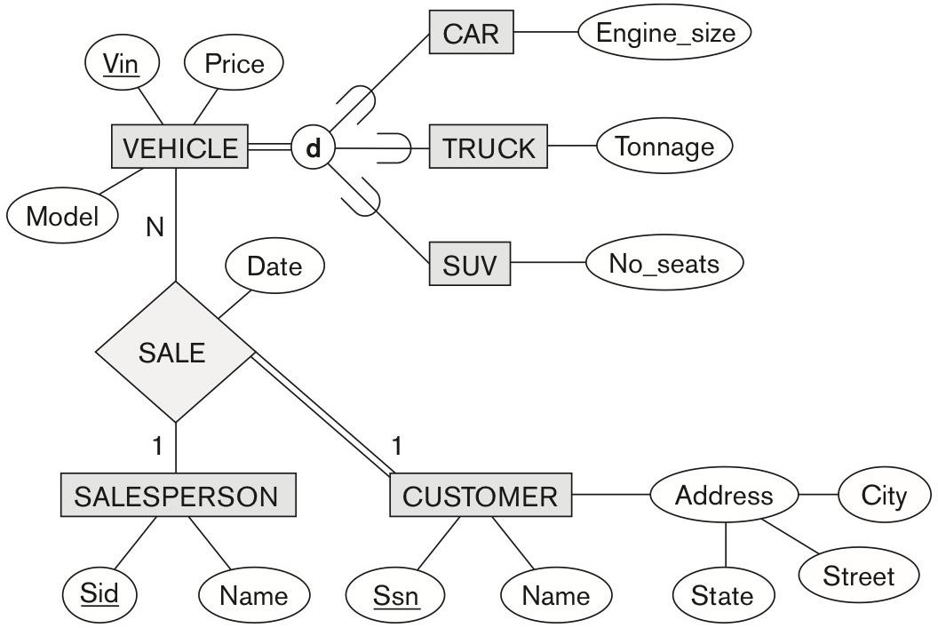

**Step 1 - mapping regular entities: VEHICLE, SALESPERSON, CUSTOMER.**

* **Regular entity type VEHICLE is mapped as a VEHICLE relation. All simple attributes are included. Attribute “Vin” is chosen as a primary key.**
* **Regular entity type SALESPERSON is mapped as SALESPERSON relation. All simple attributes are included. Attribute “Sid” is chosen as a primary key.**
* **Regular entity type CUSTOMER is mapped as a CUSTOMER relation. All simple and composite attributes are included. Attribute “Ssn” is chosen as a primary key.**

**Step 2 - mapping weak entities:**

**- N/A**

**Step 3 - mapping binary 1:1 relationships:**

**- N/A**

**Step 4 - mapping binary 1:N relationships:**

**- N/A**

**Step 5 - mapping binary M:N relationships:**

**- N/A**

**Step 6 - mapping multivalued attributes:**

**- N/A**

**Step 7 - mapping n-ary relationships: SALE**

* **N-ary relationship SALE is mapped as a SALE relation. Simple attribute "Date" is included. Attribute “Vin” is chosen as a foreign key attribute that corresponds to “Vin” in VEHICLE relation (“N” side). Attribute “Sid” is chosen as a foreign key attribute that corresponds to “Sid” primary key attribute in SALESPERSON relation (“1” side). Attribute “Cssn” is chosen as a foreign key attribute that corresponds to “Ssn” primary key attribute in CUSTOMER relation (“1” side). Attributes “Vin”, "Sid", and "Cssn " are chosen as primary key attribute in SALE relation.**

**Step 8A - mapping specializations and generalizations: CAR, TRUCK, SUV**

* **Due to being total and disjoint specializations and for database simplicity, CAR, TRUCK, and SUV subclasses of generalized VEHICLE will each represent a new relation using Option 8A. This prevents us from having redundant relations and needing more foreign keys when implementing a SALE relation because it already has a VEHICLE relation.**
* **Subclass CAR contains all simple attributes. “Vin” is chosen as a primary and foreign key. - Subclass TRUCK contains all simple attributes. “Vin” is chosen as a primary and foreign key.**
* **Subclass SUV contains all simple attributes. “Vin” is chosen as a primary and foreign key.**

**Step 9 - mapping unions:**

* **N/A**

|  |  |  |  |  |  |  |  |  |  |  |  |  |  |  |  |  |  |  |  |
| --- | --- | --- | --- | --- | --- | --- | --- | --- | --- | --- | --- | --- | --- | --- | --- | --- | --- | --- | --- |
| **SALESPERSON** | |  | |  | |  | |  | | |  | |  | |  | |  | |  |
| Sid | | Name | |  | |  | |  | | |  | |  | |  | |  | |  |
|  | |  | |  | |  | |  | | |  | |  | |  | |  | |  |
| **CUSTOMER** | |  | |  | |  | |  | | |  | |  | |  | |  | |  |
| Ssn | | Name | | State | | Street | | City | | |  | |  | |  | |  | |  |
|  | |  | |  | |  | |  | | |  | |  | |  | |  | |  |
| **SALE** | |  | |  | |  | |  | | |  | |  | |  | |  | |  |
| Vin | | Sid | | Cssn | | Date | |  | | |  | |  | |  | |  | |  |
|  | |  | |  | |  | |  | | |  | |  | |  | |  | |  |
| **VEHICLE** |  | |  | |  | |  | |  |  | |  | |  | |  | |
| Vin | Price | | Model | |  | |  | |  |  | |  | |  | |  | |
|  |  | |  | |  | |  | |  |  | |  | |  | |  | |
| **CAR** | |  | |  | |  | |  | | |  | |  | |  | |  | |  |
| Vin | | Engine_size | |  | |  | |  | | |  | |  | |  | |  | |  |
|  | |  | |  | |  | |  | | |  | |  | |  | |  | |  |
| **TRUCK** | |  | |  | |  | |  | | |  | |  | |  | |  | |  |
| Vin | | Tonnage | |  | |  | |  | | |  | |  | |  | |  | |  |
|  | |  | |  | |  | |  | | |  | |  | |  | |  | |  |
| **SUV** | |  | |  | |  | |  | | |  | |  | |  | |  | |  |
| Vin | | No_seats | |  | |  | |  | | |  | |  | |  | |  | |  |
|  | |  | |  | |  | |  | | |  | |  | |  | |  | |  |
|  | |  | |  | |  | |  | | |  | |  | |  | |  | |  |
|  | |  | |  | |  | |  | | |  | |  | |  | |  | |  |
|  | |  | |  | |  | |  | | |  | |  | |  | |  | |  |